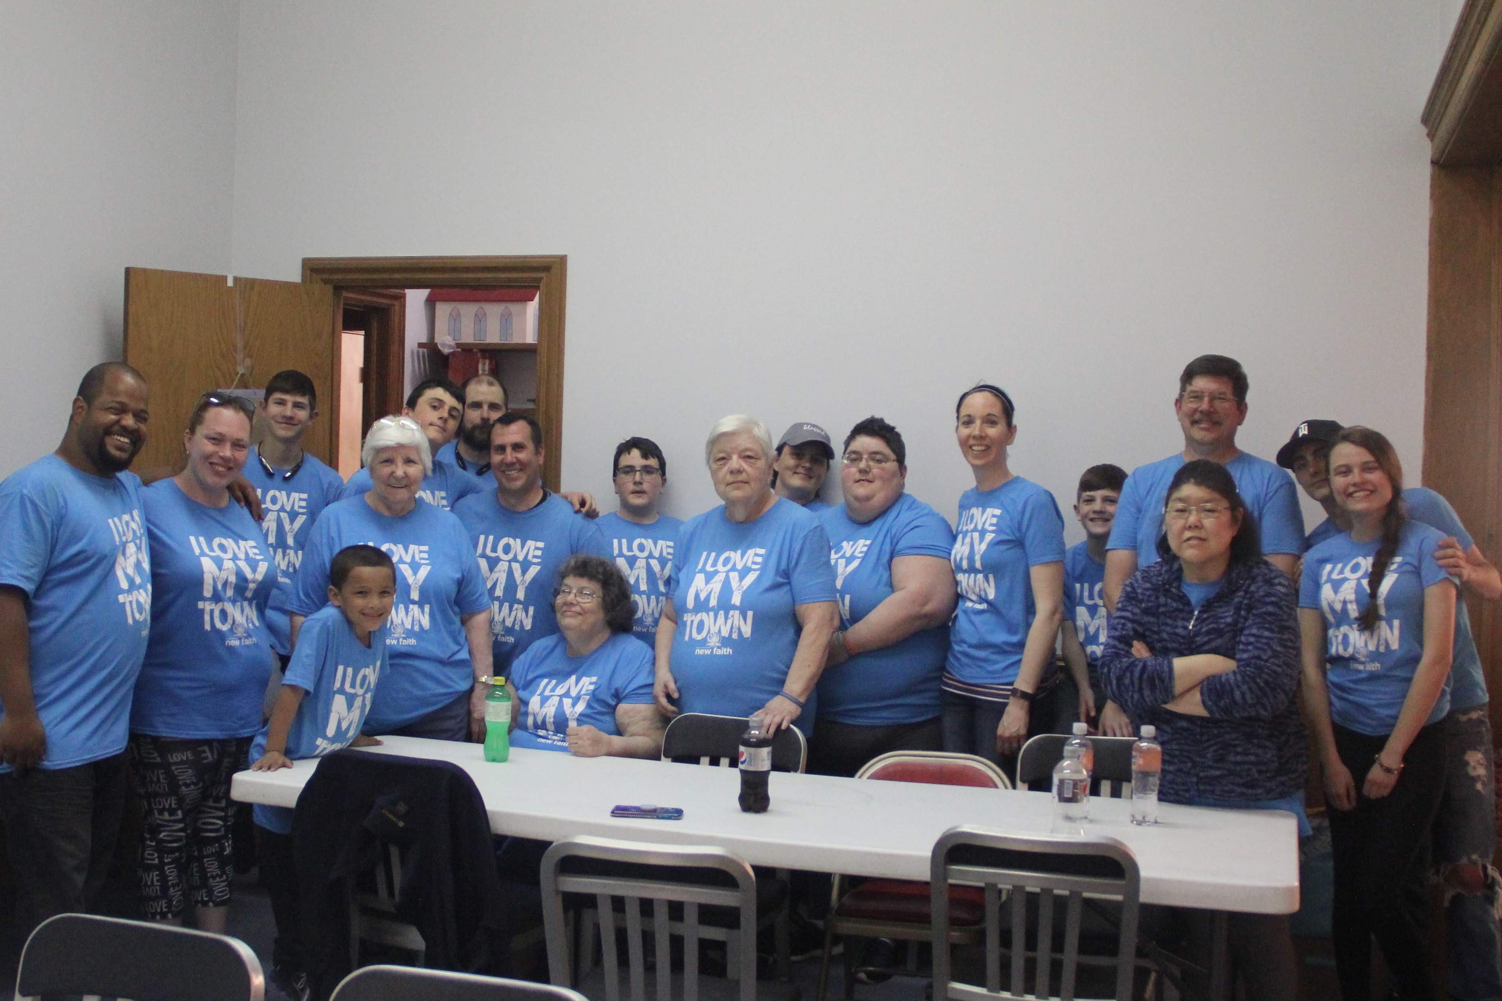 

New Faith Mission:

To proclaim the gospel of Jesus Christ in a concerted effort to lead families and individuals of the surrounding communities into a personal relationship with Jesus Christ while nurturing spiritual growth within the church family.

**Upcoming Events**

Church Elections – May 15th, 18th and 22nd

I Love my Town – May 20th and 21st

# Message Notes

### New Faith Church of the Nazarene

### 302 East Lovett St

### Charlotte, MI 48813

### (517) 719-3862

#### Service Times

#### Sunday School 10am

#### Morning Worship 11am

#### Evening Worship 6pm

#### Wednesday Evening Prayer 7pm

Jesus went throughout Galilee, teaching in their synagogues, proclaiming the good news of the kingdom, and healing every disease and sickness among the people – Matthew 4:23

🙞 🙜

Prayer Request

Pray for Ukraine and peace with the rest of the world

Diana’s nephews in Iowa diagnosed with cancer

Wendy Bahl (friend of the Surdenik’s) has cancer

Please pray for Scott, Char and the rest of their family.

Karlee Kosloski has been dealing with anxiety and her Aunt Gloria broke her hip

Carol Dvoracek, Pat Driskna, and Janet Carpenter, along with any others who are unable to come around the church.

The Haney family house has been sick please cover them in our prayers

Karen and Gene have a friend with cancer

Darlene’s brother Darrell, her sister Marcilyn, and Bob are all having health issues

Bill and Ellen’s neighbor Anita has health concerns as well as Bill Jr.

Kelly Webster has private prayer request

Noami Stairs has been placed in adult rehab for health reasons

Jackie’s sister Carri needs prayer for a family member

Friend of Karen and Eugene has cancer

Prayer Request

Eddy Smith (Friend of Surdenik’s) has cancer

Katie Salisbury

Chris’ Traci Carpenter’s significant other has health concerns

Tim Schaub – Health Concerns

Erica and Tristan private prayer requests

Amy Holden

Nadine and Fred Klaiss

Pat Spagnolia has moved to the Eagle’s Nest AFC

Jackie’s Uncle Chuck passed away

Pray for the new people who have been coming around that they may find this a place to belong …

The persecuted church, our missionaries around the world, Those who are lost, broken, & hurting Pray for Israel

Amber Adkins – Discernment and God’s leading

Lori Pratt’s daughter has been diagnosed with diabetes

Michael James Hagfors is alive and breathing! Praise God for his life please pray for him, Ross, and Jessica.

Welcome to this Lord’s Day Service May 22, 2022

**Call to worship** –

Make Me a Blessing

10,000 Reasons

**Missions Minute Video**

Just As I Am (Contrell version)

**HHM Day 22**

**Family Prayer time**

**Offertory - Pastor Duane**

**Message**

*Leading by Serving*

Acts 6, Heb. 6:10, Matt. 25:40

**Closing Music**

Build Your Kingdom Here

Batterson once wrote, **“…The greatest tragedy in life is the prayers that go unanswered because they go unasked.**”